INFORMATION FOR AUTHORS
- The editorial board accepts for publication articles by graduate students, employees of universities, research institutes, the Russian Academy of Sciences, industry, containing new results of research work that have not been published anywhere before, reviews of a problematic nature based on the latest achievements of science, engineering and technology
- The authors bear full responsibility for the accuracy of the information provided, the absence of data not subject to open publication, and the accuracy of information on the cited literature.
- The text of the article should be structured:
annotation
Keywords
Introduction
Objects/materials and research methods
Results and discussions
Conclusion/Results (Conclusions)
Bibliography
- Scope of the article should not exceed 9 typewritten pages, the total number of figures, including a, b, c, etc. - no more than 7. The volume of the review article should not exceed 12 A4 pages, the total number of figures - no more than 9. Forwarded by e-mail mail file should not exceed 3MB.
- Article textmust be submitted in the Word editor (document format *doc (docx) or *rtf). Pages must be numbered. Page margins - 25 mm. The material of the article should be presented in the following sequence (left alignment; text and bibliography in width):

UDC - Bold Times New Roman 12pt

Names of authors — Bold Times New Roman 12pt

Name of the organization
address of the organization - Times New Roman 12pt

ARTICLE TITLE — Bold Times New Roman 12pt

© Full name of authors, year - Times New Roman 12pt

Abstract - Italic Times New Roman 12pt
Keywords — Times New Roman 12pt

Names of authors in English - Bold Times New Roman 12pt

Organization name in English - Times New Roman 12pt
the address of the organization is not in English - Times New Roman 12pt

TITLE OF THE ARTICLE IN ENGLISH — Bold Times New Roman 12pt

Annotation in English — Italic Times New Roman 12pt
Keywords in English - Times New Roman 12pt

The text of the article is Regular Times New Roman 12pt; line spacing - single; red line indent 1.25; justify

Mathematical formulas.
Executed in the MathType editor. Ordinal numbers are assigned only to those formulas that are referenced in the text. The number is placed in parentheses to the right of the formula. When numbering, continuous numbering should be used. The decoding of symbols is given in the order in which they are used in the formula. Commas are placed in decimal fractions.

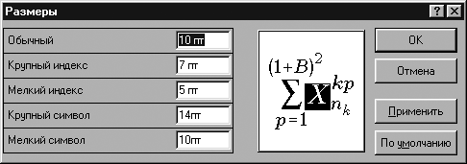 | 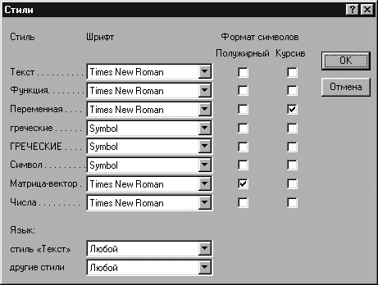

Tables and figures
All figures and tables in the article must be numbered and captioned:

Rice. one.Name; Table. 1. Name

The text of the article should have clear references to each figure and table. All figures and tables are located only in portrait page orientation. Raster and vector graphics (BMP, JPEG, TIFF, EPS) with a resolution of at least 300 dpi. Drawings should be clear and crisp, with well-detailed details. Figures should be placed in the text without text wrapping. Figure captions should be replaced by numeric or alphabetic designations, which should be explained in the caption under the figure or in the text. It is necessary to ensure that the designations in the figures correspond to the designations in the text, have the same style. Figures in the text should be consecutively numbered. In addition to placement in the text, all figures must be submitted as separate files (one figure - one file) of the appropriate format.

Bibliography
Each article should be provided with a list of references, which is compiled in the course of its mention in the text. Examples of presentation of references in the text: [1], [1]-[5], [3, p. twenty]. Footnotes are not allowed. The design of the off-text list of references must comply with the requirements of GOST R 7.0.5–2008.

- The reference bibliographic list of references should be made out of two lists:

one) Bibliography (in Russian)
2) References(transliteration [English])

- Attached to the article: accompanying documents, in accordance with the Procedure for reviewing and reviewing articles; an application containing information about all authors in Russian and English (surname, name, patronymic, position, full name and postal address of the organization, work phone, e-mail) indicating with whom to correspond

- The copyright transfer agreement (in one or two copies, depending on the need for return), is sent by e-mail.

- A complete set of documents is sent by e-mail ( Vestnik4seriya@yandex.ru ) and by regular mail with a paper version attached to the address of the editorial office. Files must be named according to the first author's last name. You can not put several articles in one file.
- The editorial board does not guarantee the publication of all submitted materials. The article will not be accepted for consideration if it is published or sent to other publications; the authors did not provide their personal data in full; text design does not meet the above requirements. The editors reserve the right to edit the article without notifying the authors.

- Articles received by the editorial board are reviewed and considered at a meeting of the editorial board. The article accepted for publication after editing and agreement with the author is printed in the journal. The date of receipt of the article is the last one after revision.

- Publications in the journal are free.

